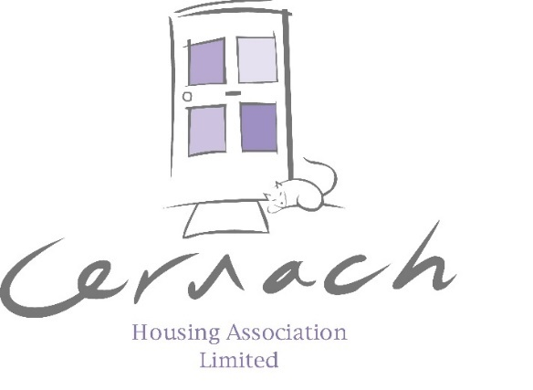

Supporting a vibrant community by offering affordable, good quality homes and services with people at the heart of everything we do.

Rent consultation
For charges from 1st April 2026

Rent Charges 2026/2027
As you know, each year we consult with you on the rent increase for the forthcoming year. It is now that time again, and our Management Committee are inviting you to take part in the rent consultation for 2026/2027. The consultation period will continue into the new year and close on 15 January 2026.


We want your views – your feedback matters, so please tell us what you think of this year’s proposal. The Management Committee will fully consider all consultation feedback and views at their meeting on 29 January 2026 before deciding on the level of rent increase to apply for 2026/2027.
This pack sets out how we use your rent to pay for the services that you tell us matters most to you, and should help you to form your view on this year’s consultation.

Last Year’s Results - We received 313 responses to last year’s rent consultation. The majority of tenants voted in favour of the rent increase which meant we could continue to provide a high-quality service and planned investment works to our housing stock. The Management Committee listened to your feedback and decided to approve a 3.5% for 2025/2026.

Income and expenditure in 2024/25
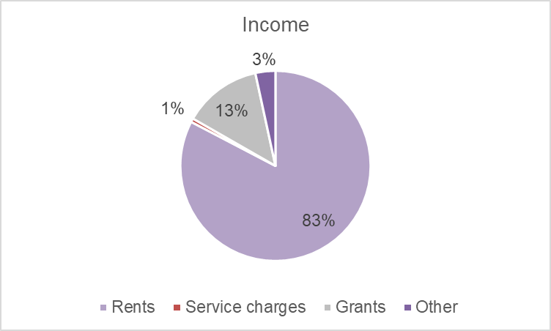
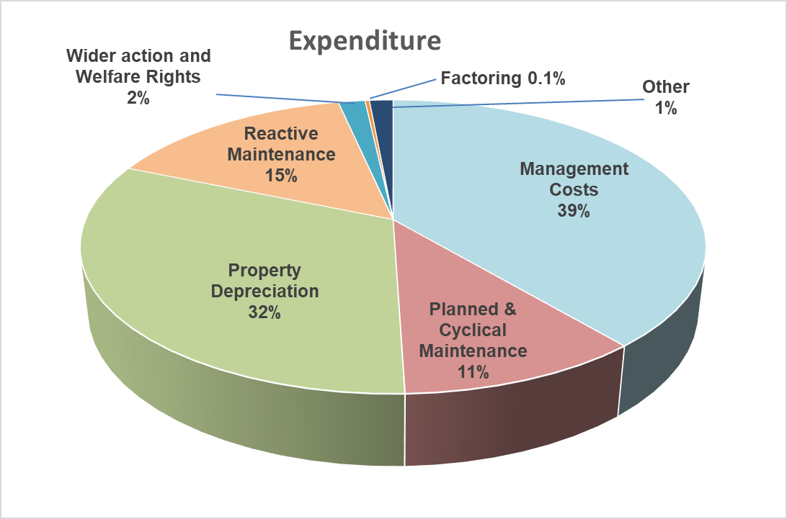

Cost Pressures
Our costs increase each year because of inflation. Inflation in September 2025, using CPI (Consumer Price Index), was 3.8% and RPI (Retail Price Index), was 4.5%. Many of our services, especially repairs and larger improvements are linked to inflation in the building industry which is at a higher rate still. By not recovering the cost increases we incur, we must use our cash reserves and may have to reconsider future planned improvement works.
As well as the impact of Covid, there is the Ukrainian War, high rates of inflation and high interest rates. We continue to see the impacts of Brexit and the Middle East conflict on our operations. These external factors impact upon the availability of building materials and labour, which increases our costs further.
Increases and finances
As you are probably aware, housing associations are charities that exist to provide good quality homes at affordable rents. We will always do our best to keep your rents as low as possible.

To pay for services and planned improvements, we review rents annually to make sure we have enough income to pay for this and that we remain financially stable to protect housing services well into the future. The Scottish Housing Regulator monitors our financial plans.

Our long-term business plan is based on rents increasing at September CPI each year. This allows us to maintain our services at a high standard and invest in property improvements over the long term. We are aware of the financial pressures on everyone because of the impact of high inflation levels and other changes in income and expenditure which is causing financial pressures for households and businesses.

After much consideration and discussion, the Management Committee and management team have found options which we believe will allow us to operate as planned whilst keeping rents as low as possible.
A rent increase of either 4.8% or 5.3% will allow the Association to continue with the existing services as last year and carry out planned improvement works in our properties.

Affordability
We are very mindful of how affordable our rents are and the impact that a rent increase will have on some of our tenants. Results from satisfaction surveys carried out during 2025 indicate that 86% of our tenants feel their rent represents very or fairly good value for money.
We recognise the current economic environment is having an impact on everyone. We must balance the high-quality services and planned improvements we deliver, whilst keeping rents as affordable as we can. Our housing management team is here to help you to manage your rent account and maximise your access to benefits. We can assist you with making claims and appealing decisions.

Planned Improvements
Our planned improvement works are developed from stock condition surveys, which we carry out independently every two years. In 2023 we updated our stock condition survey to reflect the current costs of delivering services, which you will appreciate have increased greatly over the last two years.
During 2025/2026 we carried out the final year of a two-year programme for window renewals, also during 2025/2026 we commenced bathroom upgrades. We are in the process of progressing with a kitchen replacement programme.
There continues to be a focus on the green agenda and reducing our carbon footprint. For our homes, this means considering the insulation methods and finding alternatives to gas heating systems. These come at a cost and are in addition to usual component replacement programmes for kitchens, bathrooms, and windows renewals, so must be factored into our budgets, and ultimately impact the rents which are charged. Addressing insulation and heating methods helps the environment and helps limit your energy use and associated costs.
Finally, there is continual changes to energy efficiency standard for Social Housing which are set by the Scottish Government, this is an area that we plan to invest in to further improve the energy efficiency of our homes. The Scottish Government are currently consulting upon Energy Efficiency Standards and thereafter will seek to adopt a new standard of energy efficiency for social housing.

Proposals
Now that we have explained why we need to increase rents, shown you where your rent payments are spent and explained how we consider if the increase is affordable, we are inviting you to give your views.
We feel it is important to give you some context on recent rent increases before we invite you to give your views on the rents charged from April 2026.
2024/2025 - There was a 4.6% rent increase (when September 2023 CPI was 6.7%). This increase ensured the Association could continue to run existing services and not cut back on the planned improvements works.
For 2025/26 – There was a 3.5% rent increase (at a time when September 2025 CPI was 1.7%). This increase ensured the Association could continue to run with existing services as last year and carry out the planned improvements in our properties, in line with our 30-year investment plan.

For 2026/27– we are proposing to increase rents by either (i) 4.8% or (ii) 5.3%.
These options are September 2025 Consumer Price Index (CPI) figure of 3.8% + 1% and CPI + 1.5%. We recognise tenants continue to feel financial pressures and with these options the Association can continue to run with existing services as last year and carry out the planned improvements in our properties, in line with our 30-year investment plan.
It is important to note that the Association has undertaken various financial stress testing against the business plan by using September 2025 CPI and assessed various options for the 2026/2027 rent increase to ensure that we can continue to provide high quality services to our customers and continue to invest in your homes in line with our 30-year business plan.
Given the current economic pressures, we are all facing in this challenging environment, we hope this will be viewed positively by our tenants, as it means we can continue with the existing service and planned works.

What happens next?
This consultation runs from now until mid-January 2026. During this time, you can respond by completing the consultation form and returning it to us using the pre-paid envelope, by completing the survey, or phoning us with your feedback.

Come along and see us!
We are holding drop-in sessions at our office at Marion McDonald House, 79 Airgold Drive, Drumchapel on Tuesday 9th December and Wednesday 10th December, where you can come along at speak to staff on these matters.
If you have mobility issues and require a home visit, please let us know and we can arrange this. If you, or someone you know has any communication needs, please let us know so we can provide information in a format that suits.
We want to provide you with as much opportunity as possible to speak with us and let us know your thoughts.

How can we support you?
Paying your rent on time and in full each month is your most important tenancy responsibility. If you are experiencing difficulties in meeting your rent payments, please contact us. We are here to help. Our experienced Housing Management team - Alex Kyle/Jim O’Connor, Jordan Allan and Tomi Oke can support you to manage your rent payments and your household budgeting.
Andy Parker, Welfare Rights and Tenancy Sustainment Officer provides a free, independent and confidential service to complete benefit checks to help ensure you’re receiving all your entitlements and can help with appeals.
With the rising costs of gas and electricity we can help assist our tenants with fuel support through a range of support services.
We are also here to support you and make sure you’re not left behind in today’s digital world. Whether you're navigating Universal Credit or trying to access Scottish Social Security Benefits, we can guide you every step of the way.

Please provide feedback by Thursday 15 January

You can do this by:



